03-07-2024
SPY=549
SPX=5509
VIX=12.13

Estimated 80 % confidence move with 8.95 % vol (see V-Lab: SPDR S&P 500 ETF Trust GARCH Volatility Analysis (nyu.edu) ): 545-553
Simulation with IV=10 % for today

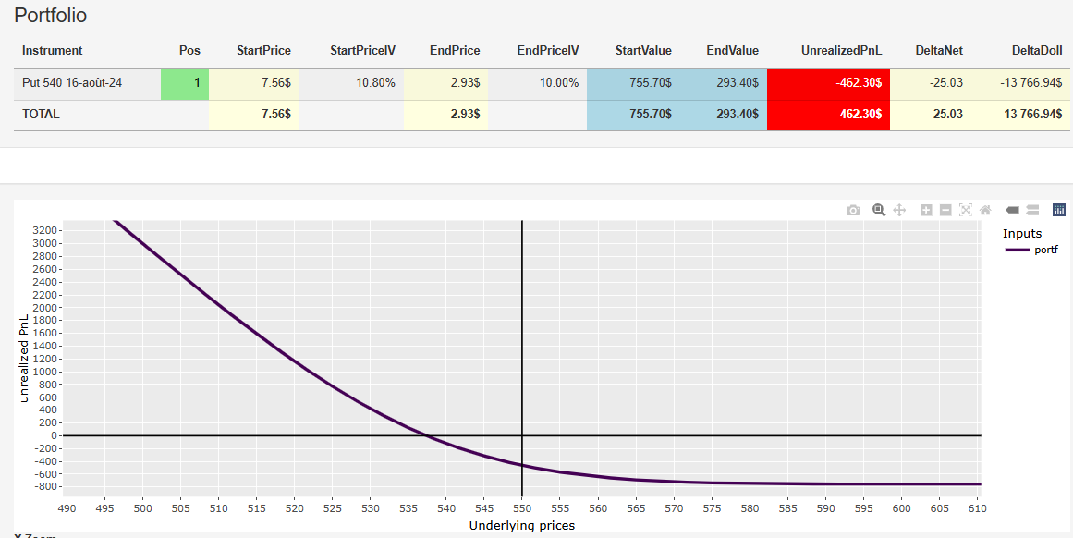
→ Get out of this trade

21-06-2024
SPY=547
SPX=5473
VIX=13.49

Instruments :
Combo SPX = Bull Call Spread + Short Put
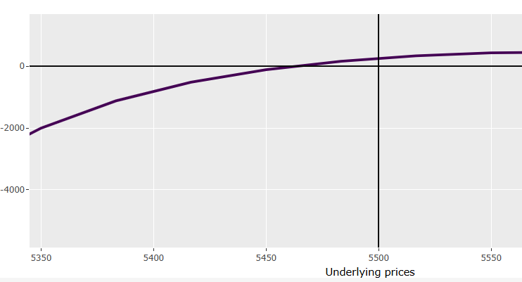

Too much volatility → sold it
-----------

SPY
07-06-2024
SPY= 535.57

Sc. 1 : unchanged vol, unchanged price
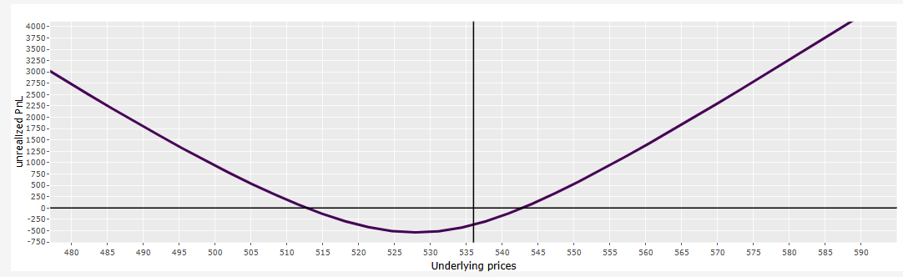

SPY
8-10-2023
- SPY=430

---

Stratégie :
Rebond probable du SPY pour une rechute ensuite

Positions :
Position | Delta : 18 | Theta : -3 | Vega : 2 | Gamma:0.003
+1 Call 430, 20-Oct | 54 | -23 | 30 | 3.346
-1 Call 435, 20-Oct | -36 | +20 | -28 | -3.343
Position | Delta : -19 | Theta : -7 | Vega : +20 | Gamma : 1.4
+1 Put 420, 27-Oct | -24 | -12 | 31 | 1.9
-1 Put 400, 27-Oct | 5 | 5 | -11 | -0.5

Conclusion :
If SPY continues to go up, buy back the Put 400
If SPY goes down, check if Call 435 worth selling
If SPY goes sideways – no action

